 |  |  | NHS
Contacting us  The Shrubbery Surgery  65a Perry Street  Gravesend  Kent  DA11 8RD  Tel: 01474 356661  Branch Site:  Riverview Park Surgery  1 Whinfell Way  Gravesend  Kent  DA12 4RX  Tel: 01474 363020  Evenings and Weekends  For urgent advice and treatment when our practice is closed, call NHS 111 | Other Local NHS Services  - Your local pharmacist will be able to give you free health advice and you don’t need an appointment. Many pharmacies operate extended hours on a rota basis. |  | The Shrubbery Surgery  65a Perry Street, Gravesend, Kent, DA11 8RD  A guide to our services

Telephone: 01474 356661

Evenings after 6.30pm and weekends: NHS 111

Opening Hours: Mon to Fri 8am-7.00pm
Mondays: Extended hours 6.30-8pm, advanced booking only

Welcome  In 1959 Dr Edeleanu had the foresight to purchase a large plot of land in the newly developing Riverview Park Estate. This plot was strategically placed at the junction of Whinfell Way, Vigilant Way and Leander Drive. The first phase, which is the present Dental Practice, was built that year. Dr Edeleanu had joined Dr Mackenzie at The Shrubbery Surgery in Perry Street that year. He also had a Surgery at 48 Lower Higham Road, which he closed.  In 1966 the second phase was built as the patient list was rapidly expanding.  In 1967 Drs Hunter and Mitchell joined The Shrubbery Practice. They had been working from premises in Park Avenue with a branch surgery in Valley Drive. These two premises were closed.  The partnership then composed of Drs Edeleanu, Hunter, Martin, Mitchell, Bee and Bourhill. | In 1974 Dr Hunter retired and Dr Shanks joined. There have been several changes in the partnership since. Drs Edeleanu, Martin, Mitchell, Bee, Shanks and Dr Todd have all retired. Dr Bourhill (Biddy) retired and has since died. Drs Hall, Herring, Sneevliet, Townsend, Westbrook and Seehra have all left for personal reasons.  The practice now consists of five GPs, Drs Bello, Yussuf, Toth, Sila, Sung and Sadon.  Our team also includes Advanced Nurse Practitioners, Physician Associates, Care Coordinators, Paramedics, Practice Nurses, Health Care Assistants, Phlebotomists, Pharmacists and a Dietician. |  | Notes

Notes |  |  |  | Our practice area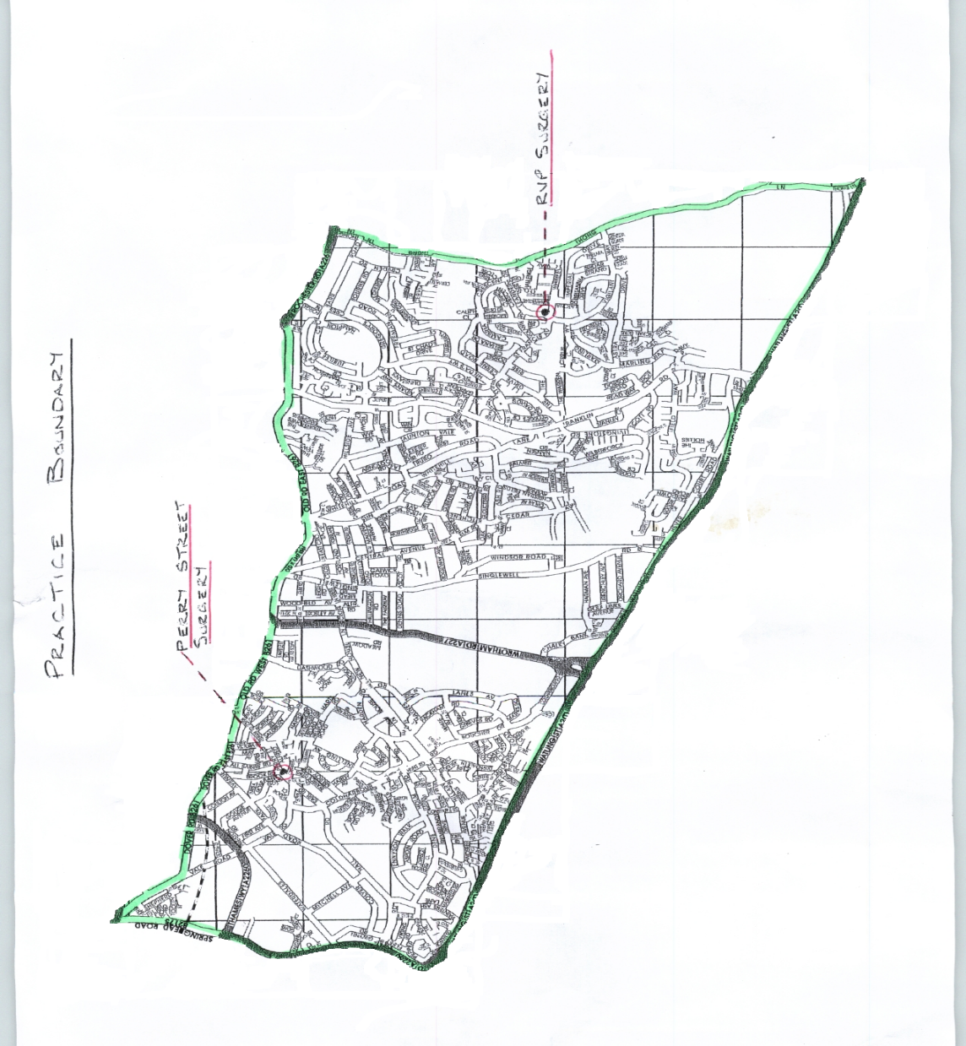
Our team  The partners  We are a partnership of General Medical Practitioners. Currently we have three partners.  Dr Bayonle Bello (male)  MB BS DFFP DRCOG (Nigeria 1985)  Dr Gani Yussuf (male)  MD FRCS (OTO) (Hungary 1988)  Dr Nina Toth (Female)  MBBS BSc MRCP MRCGP  Our salaried GPs are:  Dr Lillianne Kabanga-Sila  (Female)  Dr Melissa Sung  (Female)  Dr Kany Sadon (Female)  On-site Pharmacists  Jay – Clinical Pharmacist  Alfie – Pharmacy Technician | Our Nursing Team  Our highly qualified nurses deal with a range of conditions and health concerns. They examine patients, make a diagnosis and plan care, They are experts in many areas of disease management such as diabetes and asthma.  We also have a Health Care Assistant/Phlebotomist  Hannah Clark  Practice Nurse, RGN  Alison Templar  Practice Nurse, RGN  Clint Eastwood  Phlebotomist/HCA  Elise Wakeman  Health Care Assistant  Managers  Sheena Thorne – Practice Manager  Anne Etchells - Surgery Manager – The Shrubbery |  |  |  | Patient Data Collection  The staff at this practice record information about you and your health so that you can receive the right care and treatment. We need to record this information, together with the details of the care you receive, because it may be needed if we see you again. We may use some of this information for other reasons, for example, to help us to protect the health of the general public generally, to plan for the future, to train staff and to carry out medical and other health research for the benefit of everyone.  We are currently involved in research studies for which we provide anonymised information from patients’ notes. You cannot be identified in any way from this information as none of your personal details are given to researchers. Individual patients’ records are added into a much larger anonymous database, containing records from millions of patients across the UK. This information is used by researchers outside this practice. The database to which we contribute anonymous records is known as The Health Improvement Network (THIN). This database is managed by a company outside the NHS which does not have access to your personal details, only to anonymous medical records. The data are used for research into such topics as drug safety, disease patterns, prescribing patterns, health economics and public health. Many of theses studies provide useful information to medical staff on diseases, the use of drugs or outcomes of disease or treatment.  These studies may be performed by academic researchers or commercial companies amongst others. However, no researcher has access to your full details such as your name and address, initials or your full date of birth. The researches are not given information on the GP nor the practice name, address or postcode.  If anything to do with the research would require that you provide additional information about yourself, you will be contacted to see if you are willing to take part; you will not be identified in any published results.  If you would like to opt out of this data collection scheme, please let us know and no data from your records will be collected or used in research. This will not affect your care in any way. If at any time you would like to know more, or have any concerns about how we use your information, you can speak to our Practice Manager, Sheena Thorne on 01474 363020.

Prescriptions  Repeat Prescriptions  If you take medication on a long-term basis, you can ask for a repeat prescription.  Please tick off the required items on your repeat form and put this in the box provided in reception.  This needs to be done 2 working days before required.  We are sorry but requests for repeat prescriptions cannot be taken over the telephone line as this increases congestion and increasing the possibility of error.  If you have lost, or do not have a repeat form, then there are request slips available at reception. Alternatively your Pharmacy may provide a repeat prescribing service for you. | All new patients registering with this practice will require an appointment with a doctor for their first prescription.  Sick Certificates  We do not issue certificates for less than 7 days illness. This period is covered by self-certificates available from your employer; we do not have a supply.  If your employer is insistent about requiring a sick form then we do have a letter that you can take in explaining we are not required to provide a certificate for less that 7 days but the employers are welcome to pay for a private one.  Please fill a slip out at reception if you need a sick note. |  | Clinics  We run a range of clinics. For an appointment or further details, please call our reception team on 01474 356661  Asthma Clinic  By appointment with our nursing team.  Asthma sufferers can make an appointment for advice and support from our nurse who specialises in asthma care.  Child Immunisation Clinics  With our nursing team  Contraception clinic  You will be seen by a doctor.  Diabetic Clinic  Led by our nursing team, this clinic offers advice & health check-ups to patients diagnosed with diabetes. | Heart Risk Clinic  By appointment with our nursing team  Led by our nursing team, this clinic offers advice and general health check-ups to patients who suffer with heart conditions.  INR  By appointment with our nursing team  Phlebotomy  NHS Health Checks  By appointment and letter  With our nursing team.  Smear clinic  Our nurses run these clinics.

Appointments  Our Surgery operates a triage system where you will be called and directed to the right service within our Practice. We have advanced access, e.consult and book on the day appointments. Please call our Receptionists on 01474 356661 between 8am and 6:30pm Monday to Friday excl. Bank Holidays.  We offer extended hours on a Monday evening for patients who work full time. These appointments MUST be booked in advance.  Please remember that we are a very busy practice; despite having several telephone lines you may have difficulty getting through at times. | Tell us if you want someone to accompany you during an examination. Please remember that the results of tests can only be given to the patient. If you have mobility problems please inform the staff before they make the appointment as some of our consulting rooms are on an upper floor.  Please let us know if more than one person in the family needs to be seen. We can give you a longer appointment if necessary.  Nurses in our practice treat patients for a wide range of conditions. All these appointments can be booked in advance.  How you can help us:  ■Be on time for your appointment  ■Tell us if you need to cancel  ■Call for a home visit before 10.30am  ■Ring for test results after 2pm |  |  | Patients with particular needs  Our surgery is accessible to patients using a wheelchair.  We can arrange interpretation and translation services in person or by phone for patients who do not speak English. Please let us know if you need this service when booking an appointment.  We aim to treat our patients courteously at all times and expect our patients to treat our staff in a similarly respectful way. We operate a zero tolerance policy and take seriously any threatening, abusive or violent behaviour against any of our staff or patients. If a patient is violent or abusive, they will be warned to stop their behaviour. If they persist we will remove them from our list of patients. |  |  | Patient confidentiality  We respect your right to privacy and keep all your health information confidential and secure.  It is important that the NHS keeps accurate and up-to-date records about your health and treatment so that those treating you can give you the best possible advice and care. This information is only available to those involved in your care and you should never be asked for personal medical information by anyone not involved in your care.  You have a right to know what information we hold about you. If you would like to see your records, please call our practice manager. There may be a charge.  Disclosure of patient’s medical details or any information can only be made with the patient’s consent (except in the case of a Court Order). Necessary medical information on ‘a need to know basis’ from Doctor to Doctor will continue as it always has.
Your local CCG  The area served by The Shrubbery Surgery is in the district covered by Kent and Medway CCG.  Kent and Medway CCG is responsible for ensuring you get all the services you need. For details of all primary care services in the area via the internet,  the information you need is: www.nhs.uk  The CCG also produces Your Guide to Local Health Services.  NHS Kent and Medway Clinical Commissioning Group  Kent House  81 Station Road  Ashford  TN23 1PP  kmccg.kentandmedway@nhs.net  01634 335095 | Other information  Complaints  The Shrubbery Surgery aims to give a friendly and professional service to all our patients. However if you have any concerns about any aspect of our service, please let us know.  We operate an approved complaints procedure so if you have a complaint or wish to comment on our services please see the Surgery Manager. You can discuss the problem in a private room.  In the majority of cases, concerns can be resolved quite easily. However, if you feel we have not dealt with the issues you have raised satisfactorily you can write to the Complaints Manager at Kent and Medway CCG (address on left),  email.kmccg.complaints@nhs.net​​​​​ or telephone 01634 335095 |  |  |  | Practice times  The Shrubbery Surgery  Rive  We are open Monday to Friday 8am to 7pm with extended hours on Mondays where we are open till 8pm offering the following services:  *GPs *Physician Associate  *Nurses *Dietician  *Phlebotomists *Pharmacists  *Advanced Nurse Practitioners *Care Coordinators  *Paramedic  *Health Care Assistants
 |  |  |  |  | Home Visits  Our doctors typically see four patients in the practice in the time it takes to do a single home visit. For this reason, we ask our patients to come to the Practice if at all possible. However, if you are unable to get to the surgery and require a home visit then please telephone the surgery before 10.30am and this will be referred to a doctor. Urgent home visits after that time will be relayed to a doctor. | Evenings and Weekends  Gravesend Community Hospital Urgent Treatment Centre  - NHS 111  - Accident and Emergency  - For details, please see the following page

Other local NHS services  As well as our practice, there are many other local NHS services you can contact for health advice, information or treatment. Before you do, remember that you can treat many minor ailments such as colds, coughs and indigestion by keeping a well-stocked medicine cabinet at home. We suggest you keep the following:  ■Paracetamol and aspirin (under 16’s and people with asthma should not take aspirin)  ■Mild laxatives  ■Anti-diarrhoea medicines  ■Rehydration mixture  ■Indigestion remedy (for example, antacids)  ■Travel sickness tablets  ■Sunscreen – SPF15 or higher  ■Sunburn treatment (for example, calamine)  ■Tweezers and sharp scissors  ■A thermometer  ■A selection of plasters, non absorbent cotton wool, elastic bandages and dressings | Remember  ■Keep the medicine chest in a secure, locked place out of reach of small children  ■Always read the instructions and use the suggested dose  ■Watch expiry dates – don’t keep or use medicines past their sell-by date  ■Take all unwanted and out-of-date medicines back to the pharmacy  Your local pharmacist  Your local pharmacist will be able to give you free health advice at any time – you don’t need an appointment. Many pharmacies operate extended hours on a rota basis.  Anyone in England can register with a GP surgery. It's free to register.  You do not need proof of address or immigration status, ID or an NHS number.  If you wish to register with us please collect a registration form from reception, or download a copy from our website. |  | Gravesend Community Hospital Urgent Treatment Centre  This unit is open 8am to 8pm, 7 days a week. Please ring 01474 360816  The Urgent Treatment Centre at Gravesham Community Hospital in Gravesend works as a walk-in NHS service for patients whose condition is urgent enough that they cannot wait for the next GP appointment but who do not need emergency treatment. They also have an  X-ray Department which is open 8:30am-7pm Mon-Fri  Major accidents, injuries and illnesses should attend Darent Valley Hospital Accident and Emergency Department  Tel. 01322 428100 | Accident and Emergency/999  Whatever the day or time, if you or someone else experiences severe chest pain, loss of blood or suspected broken bones, go to your nearest accident and emergency department or call 999. Accident and Emergency Departments are open 24 hours a day, 365 days a year and can assess serious injuries and provide emergency treatment.  NHS 111  When you need medical help fast but it is not an emergency, visit 111.nhs.uk or call the NHS free phone number 111. The 111 service operates 24 hours a day, 365 days a year. If you contact 111, you will be assessed, given advice and, if needed, patients will be directed to the most appropriate local health services. Calls to 111 are free wherever you call from.  If you have a hearing problem or need help in other languages please visit 111.nhs.uk/Help/OtherWays

